**VGG19 Code**

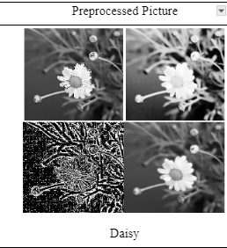

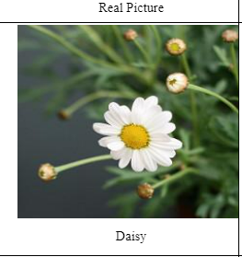

[code based on 3669 Raw images](https://drive.google.com/file/d/1VcFYeByUQBqrV0VtG8f_TiQVEABKb5FJ/view?usp=sharing) [Code based on14676 processed images](https://drive.google.com/file/d/1M8rlbGSIPRD_6pI0y_lM3GQ0BIAstR1M/view?usp=sharing)